Burnaby NewsLeader and New Westminster News Leader
Music therapy doesn't get the respect practitioners say it deserves
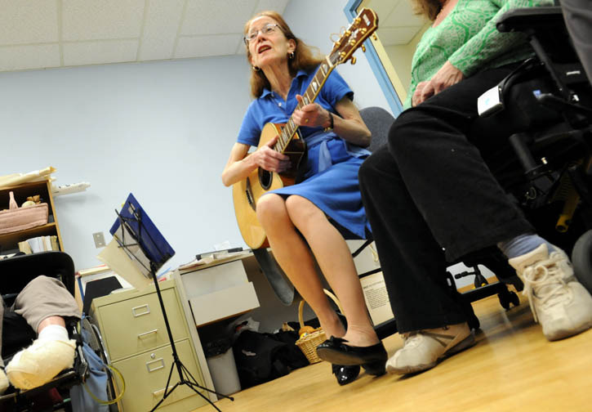
Jeremie Tucker works with patients at the Queen's Park Care Centre.
MARIO BARTEL/NEWSLEADER
Buy Burnaby NewsLeader Photos Online

By Wanda Chow - New Westminster News Leader
Published: February 14, 2012 1:00 PM
Updated: February 14, 2012 1:42 PM

Meaghan Jackson sees minor miracles at her job on a regular basis.
A music therapist at St. Michael’s Centre in Burnaby, she regularly works with extended care residents with dementia.
“We have residents who are unable to speak or who can’t tell you their name, or can’t remember who I am or can’t remember who they are. The minute I start singing they start singing along as well and smiling and interacting. It’s really quite amazing to see.”
Jackson said her work is aimed at improving the quality of life of everyone involved, and can assist patients’ health from physical, social, cognitive, emotional and spiritual perspect
Centre staff have noticed that following music therapy sessions, residents are in better moods, less agitated and require less medication and attention.
Jackson does vocal and mouth exercises with some patients to improve their swallowing abilities, which can be impaired due to a stroke or dementia. She helps mount an annual musical production, so “residents have an opportunity to shine in the spotlight,” performing in roles that suit their abilities.
And for residents at St. Michael’s Hospice, she teaches relaxation techniques to help terminally-ill patients sleep and to express pent-up emotions, even say goodbye to friends and family. One way she does that is to help the patient write and record a song, which serves as a legacy for their loved ones.
It’s all work that Jackson, like most other music therapists, does through a part-time position.
But there are some that feel even those part-time jobs are under threat by health regions’ restructuring efforts.
Not always a valued profession
The last major round of job cuts affecting music therapists in B.C. took place in 2002, said Susan Summers, president of the Music Therapy Association of B.C.
But about two years ago, the Interior Health Authority cut music therapists in a restructuring that the association found unsettling.
It decided to standardize its services so that each hospital has the same staffing levels, Summers said. Unlike nurses, who usually number in the hundreds, if there is a music therapist in a hospital there’s usually only one working part-time.
“We’re not everywhere.”
So instead of hiring more music therapists to ensure all hospitals had the service, Interior Health cut all the ones it did have, so no one had it, Summers said.
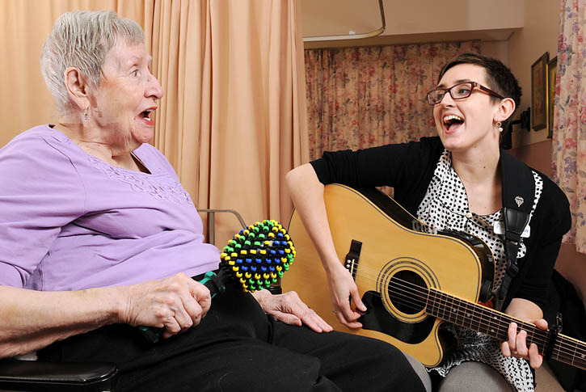
“They said, ‘we’ll have volunteers come in and play CDs,’ which is insulting let alone they haven’t a clue what we do.
“In general, music is so pervasive, people kind of get the idea of the therapeutic aspect but they don’t always know it’s a trained profession,” said Summers, who teaches at Capilano University, the only provider of music therapy training in B.C.
Fraser Health has not announced any cuts to music therapists, she stressed, but the association remains concerned nonetheless because the health authority appears to be considering the same sort of standardization as its Interior counterpart.
Music therapists assist people through the entire life span, from birth to death. It can be effective in treating autistic children and people who can’t speak, to people with behavioural problems, dementia patients and people nearing the end of their lives.
“We meet people where they’re at,” she said of music therapists.
“They don’t have to have language, cognition or a verbal response.”
‘It brings everyone together’
At Queen’s Park Care Centre in New Westminster, an elderly Chinese lady taps happily on a drum. She may not speak English, but she can still participate in sessions with music therapist Jeremie Tucker.
Tucker, who has been plying her trade since 1978, said music “bypasses all the grey matter” and can stimulate emotions, memories and motivation.
One lady resident couldn’t see or hear very well but could still play violin and piano. Tucker arranged for a keyboard to be placed in her room to allow her to practise and perform concerts.
“She just blossomed,” Tucker said. “She said to me one day, ‘If I don’t do this, I wouldn’t do anything.’”
Another woman started mostly in bed and isolated, and “now she’s the life of the party.”
Tucker also leads group songwriting sessions where residents can unload frustrations.
A large lyric sheet on the wall of a recent work highlights this: “If you want to know what it feels to be me, Start rolling around in a borrowed wheelchair, Even though I’m in this chair, I have true feelings too...”
Resident Trudy Barnes, 93, is a big fan of the music therapy program.
“It’s not the easiest place to live, with the different types of people that are here,” she said. Without music therapy, “it would be very lonesome in a way. It brings everyone together.”
Even people who aren’t already musical can participate, with the hand-chime class allowing residents to perform according to numbered cues.
“Some of them look like they’re sleeping, then all of a sudden out it comes,” Barnes said with a laugh.
The Music Therapy Association of B.C. is hosting a screening of the documentary, The Gift of Music: Stories of Music Therapy, at the Vancity Theatre in Vancouver on March 29, 7 p.m. Info: www.mtabc.com/page.php?177.

