Delta Optimist article
March 7, 2012

http://www.delta-optimist.com/health/Photos+Therapy+comes+with+song/6263563/story.html

Photos: Therapy comes with a song

Residents at hospital's Mountain View Manor find stimulation in the music

BY JESSICA KERR, THE DELTA OPTIMIST MARCH 7, 2012

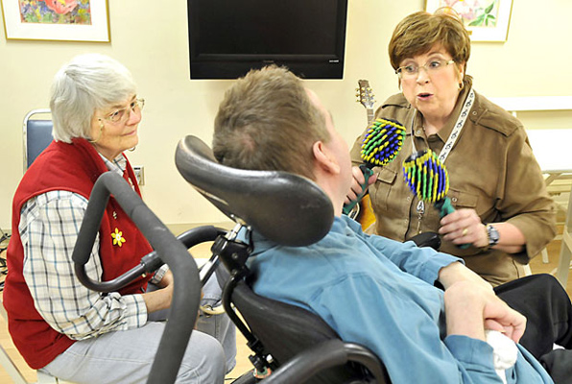

Music therapist JoAnne Tait engages her clients through instruments and song.

Photograph by: Chung Chow , Delta Optimist
"Are you ready to work?" music therapist JoAnne Tait asks Brian* as she starts in on the first song of the session.
Her fingers deftly glide over the strings of her guitar and she sets her sights on her client as she starts to sing.
***
"I love to go a-wandering,
Along the mountain track,
And as I go, I love to sing,
My knapsack on my back."
***
Tait isn't just performing for Brian. As an accredited music therapist, she uses various active and receptive techniques, such as singing and playing instruments, to engage and benefit her clients depending on each one's individual needs.
Brian, a resident at Mountain View Manor - Delta Hospital's longterm care facility - is nonverbal, but can make some sounds, and is confined to a wheelchair. He has limited mobility is his upper body and communicates by blinking his eyes, clicking his teeth together and using limited hand gestures.
His connection with Tait is evident. As she sings, his eyes light up, his smile is wide and he often reaches for her hand as she plays.
***
"Val-deri, Val-dera, Val-deri, Val-dera-ha-ha-ha-haha..."
***
Tait pauses in an attempt to coax Brian to join in on the laughing part of the chorus of The Happy Wanderer.
Due to his condition, Tait says, he only makes sounds while he is inhaling. She is trying to help him make sounds while exhaling, as most people do while talking, in an attempt to get him to use his voice more and increase functional communication.
"Singing can help with breath support," she says.
Essentially, music therapy is the practical application of the elements of music to help clients meet beneficial, predetermined (often nonmusical) goals.
When she is working, Tait is intensely focused on her client. As she is singing and playing, she is monitoring the level of engagement. On this day, she feels something more is needed and asks her volunteer assistant to get out the tambourine "for a bit more stimulation."
No two music therapy clients are the same and Tait approaches each one a little differently.
Betty Ascott moved into Mountain View Manor more than two years ago. Originally from Kent, England, she moved to Canada in 1964. Her session with Tait starts with a simple conversation about songs from Ascott's younger days. The reminiscing soon turns to singing and the two women sing several old favourites together.
***
"My old man said, 'Follow the van,
And don't dilly dally on the way.'
Off went the van with me home packed in it,
I followed on with me old cock linnet.
But I dillied and dallied, dallied and I dillied
Lost me way and don't know where to roam.
Well you can't trust a special like the old time coppers
When you can't find your way home."
***
Ascott says the music and singing brings her an energy.
"I'm not a young woman anymore but I can get myself going," she says with a laugh, adding music was a big part of her life, especially in her youth.
"I used to go to church just to sing in the choir."
Tait says it's her job to structure the musical environment to help clients meet individual needs or goals. Knowing their background helps.
As an accredited music therapist, Tait is keenly aware of the therapeutic power of music, how it can be used to help clients meet pre-assessed needs and how it can evoke memories, mental images and emotions.
Tait says, especially for her older clients, hearing or singing an old song can mentally take them back to happier times in their lives.
The sensory nerves of the auditory pathway provide an almost direct route to the brain's limbic system - the centre of emotions, memories and images - and the endocrine (hormone) and nervous systems.
These systems form a mind-body connection, which Tait can tap into through her music. Memories of better times, which can sometimes be triggered by music, evoke thoughts and emotions that can influence the body.
A song that evokes memories of happier, healthier times can help reduce cortisol levels (a hormone released as the body's response to stress) and increase other beneficial hormones that restore balance and promote relaxation, Tait says.
Those who oversee the operation of Mountain View Manor say music therapy is hugely beneficial to residents.
"It just adds on to the home-like atmosphere," says manager Connie Lau.
Music therapy can touch other patients in the hospital as well.
It can be helpful for patients in the acute care ward or those in palliative care. Tait is often called on to help patients and their families cope with serious illness, a protracted hospital stay, transition to residential care or assisted living and end of life care.
Dr. Sylvia Henderson, who has been at Delta Hospital for 15 years, says the affect of music therapy on patients, their families and even staff is palpable throughout the acute care ward.
"One of the most noticeable effects is the settling of patients who are agitated as a consequence of delirium, or dementia, or both," she says. "There is a calming effect on virtually all such patients."
The presence of music on the ward also benefits staff, she says.
"As one of the staff who loves music (especially jazz), I find myself singing, mostly silently but sometimes aloud and sometimes jointly with other staff.
That engagement is hugely therapeutic as an antidote to the losses and suffering that one must witness in medical work," Henderson says. "Subsequently, my thoughts are clearer and my efforts are more efficient.
"Music heals and promotes smiles and good human interaction; there is relief of distress even if there is no change in the medical status of the patient."
There wouldn't be as much music at Delta Hospital without funding from the Delta Hospital Auxiliary, which spends more than $30,000 a year to maintain the service.
Auxiliary representative Elaine Canning, who is also the area representative for the Lower Mainland/Fraser Valley B.C. Association of Health-Care Auxiliaries, says the organization saw the benefit of music therapy for both long-term residents of Mountain View Manor and the acute care patients at the hospital, so in 2010 committed additional funding to increase the number of music therapy hours.
"It's worth every penny," Canning says. "We saw what a difference it made in the patients' lives."
Kate Donaldson, recreation therapy supervisor at Mountain View Manor, says the auxiliary is hugely supportive of the little extras to residents, such as bringing in high quality entertainment, the garden and greenhouse - both of which are specially designed to be wheelchair accessible - and the pet program.
The auxiliary was started in 1969 as a fundraising organization supporting and promoting the concept of a hospital in Delta. In 1977, that dream became a reality with the opening of 100-bed extended care unit. When the acute care unit opened in 1980, the auxiliary was restructured.
Over the years, it has raised millions to help keep equipment current and to make sure patients and residents of the extended care facility are comfortable. Its volunteers help keep many programs and amenities running like the gift shop and Courtyard Café.
A large part of the auxiliary's revenues come through sales at its thrift shop in Ladner Village. The sale of gently used clothes and household items has, over the years, helped raise $1 million to the expansion of the emergency room, another $250,000 to the extended care unit and $700,000 for the purchase of digital mammography equipment.
In its more than 40 years of existence, the auxiliary has raised more than $10 million for Delta Hospital.
* Name has been changed.
jkerr@delta-optimist.com
© Copyright (c) Delta Optimist

- JoAnne Tait
- Delta Hospital
- Betty Ascott
Read more: http://www.delta-optimist.com/health/Photos+Therapy+comes+with+song/6263563/story.html#ixzz1oar8iOaS

