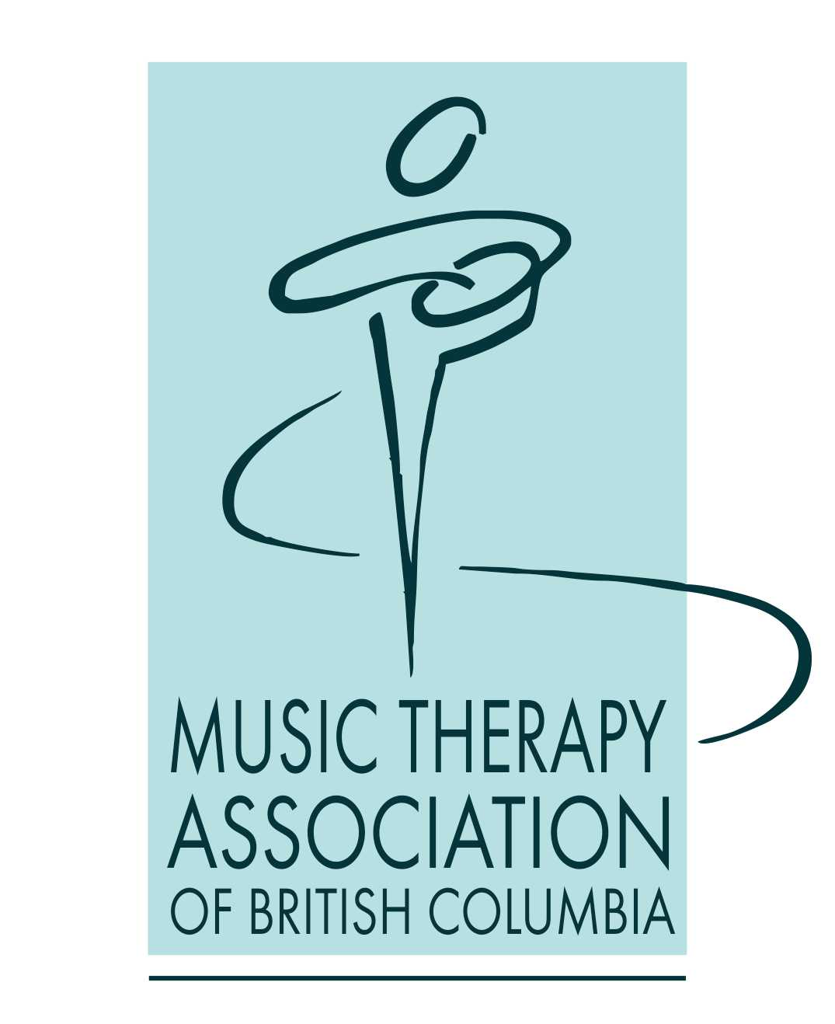

Summary of government policies and information
concerning the COVID19 pandemic

Compiled by Susan Summers, PhD, MTA
MTABC Director of Advocacy
Covering the period from March 16- June 29, 2020
Approved by the MTABC board for distribution June 29, 2020

Table of Contents
Introduction 2
Partnership and advocacy campaign with HSA 4
BC government and Provincial Health Officer ministerial orders 5
MTABC members work in a diverse and varied way 6
Recent developments: Island Health directive about singing 8
What does all this mean for you in your work? 9

Introduction

This document is a compilation of information about the pandemic response. It includes ministerial orders, information, and advocacy advice for MTABC members. It is intended to help our members navigate the many new developments, guidelines and concerns that the pandemic response has engendered.

While the province is about to enter stage 3 of the re-opening, many MTA’s are still waiting to be able to go back to work after not being able to see clients since mid-March, while others have been deemed as essential services and have been working consistently since COVID19 changed our world. We know how difficult this period of time has been for many of our MTABC members, whether you are waiting or working.

Who to contact at MTABC with questions or have concerns:
Sheila Lee, President: president@mtabc.com
Susan Summers, Director of Advocacy and Gov’t Regulation: regulation@mtabc.com

Current resources and supports
Your MTABC board has been discussing the best ways to support you, our members.

Resources: MTABC has created and compiled resources which you will find on our website. You can also access COVID19 resources on the CAMT member’s area of their website. There are also excellent resources on the HSA website (www.hsabc.org and specifically covid19hotline@hsabc.org; hotline available 8 am to 5 pm Monday to Friday: 1-604-549-5168).

Support meetings and workshops: MTABC held a discussion with 50 members post-AGM on April 5 and organized a CE workshop about using telehealth on May 6. CAMT is holding biweekly open conversations with members. We have continued to hear from you through Facebook and direct communication about your situation and your concerns. We anticipate future CE workshops to address issues of relevance and concern at this time and are open to your ideas, so please let us know what you need.

Survey: We sent out a survey on June 10 to hear about your current situation and help us devise a strategy moving forward. Although there are challenges, there are also unique opportunities that have not been accessible before. We are currently analyzing the data with the hope it will help us understand our member’s situations, what the issues are, and what concerns and possible solutions might be available, including future CE workshops, webinars, and focus groups. Thanks to those who completed the survey.

Partnership and advocacy campaign with HSA

One of the current MTABC projects is to formalize relevant partnerships and a subsequent advocacy campaign with stakeholders, health authorities, employers, and Health Sciences Association (HSA) union, with the ultimate intent of ensuring that music therapy is considered an essential health care profession now and into the future. Health care is an industry that is vast and complex. MTABC and music therapy forms a very small part of the whole and thus we have to partner with larger organizations from various health sectors to advocate for our profession being seen as essential and for them to know about what music therapy is.

We are planning an educational webinar with HSA in July about worker’s rights in BC, helping you to know:
- what your rights are according to the BC Labour Code
- what occupational health and safety standards you can be assured of in any of your work settings
- how to understand your work in terms of being employees, independent contractors, and/or dependent contractors, especially in light of the COVID19 orders, but also with the health science professional’s collective agreement
- what being unionized is, and what HSA is
- how to advocate for yourself with our current work sites/employers
- how to have a more informed voice with your future employers/sites

MTABC is one of more than 50 professional associations that are invited twice a year to attend an HSA-sponsored meeting to share and discuss issues of mutual concern. It is always useful to hear from our interdisciplinary team members who have some similar concerns but often have the ear of employers and health authorities because they are primarily employed in the health system and have huge numbers of members. It is also useful for our colleagues in allied health professions to hear about the issues that certified music therapists have.

BC government and Provincial Health Officer ministerial orders

Single site transition framework

For many of you, you have been asked in the past few weeks to choose one site to work at in alignment with the BC government’s April 10 “single site transition framework” (Ministerial order no. M105 under the Emergency Program Act as an Order of the Minister of Public Safety and Solicitor General). This states that each employed/unionized health care worker within the same labour adjustment term will choose one site to work to prevent cross-contamination of COVID19. https://www2.gov.bc.ca/assets/gov/public-safety-and-emergency-services/emergency-preparedness-response-recovery/gdx/orders-april-10/ep_act_order_m105-2020_single_site.pdf

Of note for music therapists especially:
- definitions: labour adjustment terms, single site order, single site transition framework, staff
- Additional worksite assignment principles and process points 5 through 13

Facility Staff Assignment order (April 15, 2020)
This updated Provincial Health Officer order sets out the current group of facilities/employers/employees that are impacted by the limitation of employees to one site (long term care facility staff assignment): https://www2.gov.bc.ca/assets/gov/health/about-bc-s-health-care-system/office-of-the-provincial-health-officer/covid-19/covid-19-pho-order-long-term-care-facility-staff-assignment.pdf. Both these orders are meant to work together, and it’s important that certified music therapists understand them as they apply to their specific work situation.

Of note:
- P. 2 (G) designates an exemption from the single site framework for many of our interdisciplinary members (but not specifically include music therapists).
- P. 2 (H) might be of importance for those of you who work in social services.
- P. 6 (under Medical health officers must and point 2), there is a possible way that contract music therapists could discuss with their site/employer asking them to apply for an exemption to allow music therapists to work.
- P. 7 this is also repeated in “Operators point 3” and “Contractors and Sub-contractors who provide staffing for facilities point 3”.

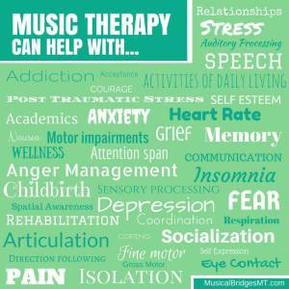

MTABC members work in a diverse and varied way
We recognize that this is a lot of information to read, understand and apply. MTABC attempts to support all our members, no matter where and how they work. We recognize that there are at least five categories of types of work that our members are engaged in, and that these documents may not address all:
- those who are employed and/or unionized
- those who are in contract practice
- those who are in private practice
- those who do subcontract work from business owners
- those who are working in educational settings, non-health care settings, etc.

Because each of our MTABC members works with different clientele, in a variety of institutions and agencies, as contractors, employees, unionized workers or in private practice, and with a unique set of circumstances, there is no one “right” way for MTABC to guide you in how to return to work and how to advocate for yourselves now and in the near future, given this “new normal” going forward. The information we have provided is meant to help you understand what your rights are as a worker, and in accordance with the government policies that govern our employers.

For those of us in private practice, we have not addressed that work here. It will depend on whether you have clients to your studio or home, whether you are working in long term care or schools, and the type of work you do with your clients. We know many have transitioned their practice to telehealth, at least in the short term.

We also have not addressed business owners’ practice here. We hope to offer our business owner members a CE workshop in the near future that would benefit and be relevant to your specific needs. Please contact our CE chair, Lorri Johnson to offer your ideas: lorri.mt@gmail.com

Employees and unionized employees: from the MTABC membership directory, there are nearly 40 MTA’s who are HSA or BCGEU members who work under the health science professionals’ collective agreement. For those who are employed and/or unionized in more than one site within a sector (long term care and/or seniors especially), you will have been asked to work the total of your hours at one chosen site and no hours at your other site while the single site order is in place (till the end of August currently). The MTA will be placed on a COVID-related unpaid leave of absence at the second site for the duration of the single-site limitation which leaves the second site without a music therapist’s services. MTA’s who have been deemed essential services may have an increase in their hours at their one site and will qualify for and be able to apply for the additional government temporary pay of $4/hour pay for 16 weeks from March 15 (likely to be a lump sum payment). This includes casual workers who have worked hours during this time. No employee’s status will change as a result of the Single Site order.

Music therapists on contract: for many of our MTA members who work at well over 100 sites on contract in long term care homes and community agencies, there seems to be a mixture of work situations. Some of you have continued to work in-person throughout the pandemic, but many have not been allowed to see clients in person and this has had major impact financially, professionally, and emotionally. Some of our members have transitioned their clients to telehealth sessions, some with mixed results, but as a way of keeping connected with our clients and offering therapeutic support. All health care employers have been ordered to comply with the single site policy for all staff as well as contractors for the safety of their senior residents and clients. However, music therapists may fall in a grey area of how we are defined as “contractors” according to the government’s use of the term in these orders.

Recent developments: Island Health directive about singing

On June 23, some of our Vancouver Island MTA’s who work in long-term care received notice from their managers that they were now aware of “evidence of risk of increased viral spread related to singing” after discussion with the Ministry of Health office.
“There will be directives coming out related to activities involving singing and until those are available, Music Therapists are not considered essential workers in LTC. We recognize that some residents benefit from one to one interaction with Music Therapists but for now we need to restrict this activity”.
They indicate that there will be provincial guidelines on activities involving singing and for non-essential family visits coming soon for long-term care and assisted living.

That singing may be a high-risk activity is not new news. We have been aware of media articles since mid-March detailing choir experiences in Skagit Valley in Washington state, Berlin and Amsterdam. CAMT released a statement on singing on June 8, including the most recent information available at that time. With information and research about COVID19 changing on a frequent basis and with many subsequent articles questioning the assumption that singing was the root cause of the high transmission in these choir situations (instead of sitting close together, no masks, for an elongated time in a contained space), we can’t be sure how risky singing is. However, as health care professionals, we must adhere to strong risk assessment and management, using PPE, distancing and minimizing anything that may cause viral transmission.

In Mr. Orr’s directive, he writes “music therapists are not considered essential workers in long term care”. Two of our members experienced being prevented from doing their work and/or being sent home from their work site upon their managers receiving this directive. What may be useful for our members to know is that the term “essential worker” is usually reserved for use during a strike, when the union and employer agree upon minimum essential services staffing levels. The current use of “essential service workers” in the COVID landscape is not the same thing. HSA has told us they consider music therapists’ work to be essential to the clients we serve, and as a union, they have the power to file a grievance for wrongful layoff. Unfortunately, as contract music therapists, we are on our own with our employers and don’t have the same authority. We can advocate for ourselves as essential to our client’s wellbeing.

MTABC is in contact with our health care partner organizations with the intent of informing, educating, and advocating for all music therapists to be considered essential services for the work we do (as our employed/unionized MTA’s are) and be able to continue to offer therapeutic music therapy services to our clients, staff and work sites. If you are interested in being involved in this advocacy initiative, please contact Susan.

What does all this mean for you in your work?

What we can do is share some ways that your colleagues have been navigating these times and what might be options for you to discuss with your manager, employer and site. Keep in mind to keep yourself healthy and safe, as well as your clients.

- If you are contracted to a specific site, explore with them the possibility of them employing you (they may have vacant positions and/or sufficient budget). It doesn't hurt to ask and there have been instances we know of in the past few months where the answer has been yes. As an employee, you would most likely be eligible to work, as well as gain other benefits.

- Any worker in BC has a right to explore union membership, no matter how you are paid (operational budget, donations, foundation, grants, etc.). You can contact HSA for further information and are encouraged to attend our July webinar to find out more. www.hsabc.org

- Speaking specifically about long term care, it is not known what will happen post-pandemic with the single site framework and whether there will be recognition that having all staff at one site is actually not only safer and healthier for the residents, but also for the staff. Music therapists have been historically under-hired at our work sites. If you have had increased hours which has given you the opportunity to introduce new programs, expand your referrals and client base, and meet the needs of specific people in a creative, unique way, write about it and submit a report or article to management and e-newsletters at your site. Submit a proposal and talk to your leadership about retaining your expanded hours and use the last few months as proof of why music therapy is needed in the ways you have been working and the client needs you have been serving.

There is much talk about bringing long term care under the Canada Health Care Act and if this occurs, there may be funding from federal or provincial governments for much needed extra staffing. This likely won’t be a factor in the short term. Music therapy should be recognized as an essential service for residents in long term care and this timing may provide the opportunity for that. Depending on what happens with the single site framework going forward, this may open second sites to other MTA’s and/or expand the work that certified music therapists are able to do when they have sufficient number of hours at a particular site.

- If you are contracted at a specific site, consider discussing upgrading your contract to include minimally health benefits for you when you do return to work. If you were to get ill at work (due to COVID19 or another reason) and have to quarantine for 2 weeks again or longer, enquire whether you would be covered under your employer’s Worksafe BC’s coverage. They already have this coverage for their employees. This may depend on the status of your contractorship. Be confident to ask for what you need to remain safe and feel supported.

- Discuss with your manager and site about your work and how you can make it safe to be in person with your clients. Many of you are talking with fellow MTA’s about what they are doing for physical distancing, not using instruments or books, how to use other interventions besides singing, etc. Perhaps consider partnering with some peers for the next weeks for peer supervision and support. Write and share about your innovative and creative approaches with health authorities, the newspapers, and organizations. You are not alone in your questions and in your needing to be adaptable now.

- For anyone who is an HSA member and/or has questions concerning the single site policy and your unique contract situation, Labour Relations coordinator Sheila Vataiki has offered to talk to our members. Please call her at: 604-916-1756.

- If you have not already joined the MTABC private group Facebook, there are conversations going on there to share ideas, ask for support, check in regarding what is happening with other MTA’s.

- Please contact MTABC first with your concerns, questions and to inform us of any situation occurring in your work sites. We will do our best to advocate for our members and for their rights, but we must be informed about them.

- Please write an article for our next Drumbeat (deadline July 31) about your work, your thoughts and opinions, and new learnings or awareness about the last four months during the COVID19 pandemic.

These are unprecedented times for everyone. Many of you may be exhausted and stressed physically and/or emotionally, knowing there are uncertain times ahead. This time calls for us to think creatively and to be adaptable and flexible. Please continue to openly share with your colleagues, inform MTABC and CAMT so that your professional associations can support you and advocate on your behalf, and above all, take good care of yourself.

Stay tuned for further updates as they become available.

